**DAY 1**

**WHAT IS SQL:**

sql is the standared language for dealing with

relational database it can be used to create, read,

update and delete database records.

sql stands for structured query language and is used

for communicating with the database.

**NORMALIZATION:**

Normalization is the process of reducing data redundancy

by organizing fields and table of a database.

Insertion anomaly, update anomaly, and deletion

animaly it is a database design technique.

**CONSTRAINTS IN SQL:**

constraints are used to specify rules for data in table.

1.Not null:

Not null constraints ensures that a column cannot

have a null value.

2.Default:

Default constraints sets a default value for a column

when no value is specified.

3.Unique:

Unique constraint ensures that all values in a

column are different.

4.Primary key:

Primary key constraint uniquely identified

each record in a table.

5.Foreign key:

Foreign key is used to link two tables and

it refers primary key.

6.Check:

Ensures that the values in a column

satisfies a specific condition.

**DATA-TYPES:**

The data type of a column defines what

value the column can hold integer, character, money,

date and time, binary and so on.

Numerics:

The exact numeric data types are SMALLINT,

INTEGER, BIGINT, NUMERIC(p,s), DECIMAL(p,s).

Exact sql numeric data type means that the

value is stored as a literal represntation of the

numbers value.

character:

Stores string of letter, numbers, and symbols

data types CHAR, VARCHAR are collectively referred to

as character string types and the values of character

string types are known as character strings.

DateTime:

In sql datetime dete date type is used for values

that contain both date and time.

**DAY 2**

**CREATING DATABASE :**

The CREATE DATABASE statement is used to create a new sql database.

Syntax:

CREATE DATABASE database name;

Example:

create database Training;

use Training;

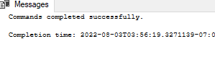

**CREATING TABLE :**

The CREATE TABLE statement is used to create a new table in a database .

* Name the table
* Define the columns
* Assign data type of columns

Syntax :

CREATE TABLE table_name (  
    column1 datatype,  
    column2 datatype,  
    column3 datatype,  
   ....  
 );

Example:

create table student(

s_id int identity(100,1),

s_name varchar(20),

s_age int check(s_age>15),

s_gender varchar(20),

s_department varchar(20),

s_location varchar(20)

);

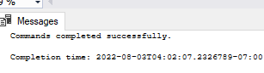

select * from student;

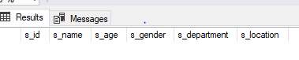

|  |  |  |  |  |  |
| --- | --- | --- | --- | --- | --- |
| S_id | S_name | S_age | S_gender | S_department | S_location |

|  |
| --- |
|  |

**SQL INSERT INTO :**

The INSERT INTO statement is used to insert new records in a table

Syntax :

INSERT INTO table_name  
VALUES (value1, value2, value3, ...);

Example :

insert into student values('jacob',21,'male','cse','Tirunelveli');

insert into student values('williams',21,'male','cse','chennai');

insert into student values('james',18,'male','civil','mumbai');

insert into student values('nancy',23,'fmale','ece','chennai');

insert into student values('priya',25,'fmale','eee','madurai');

insert into student values('victor',29,'male','mech','salem');

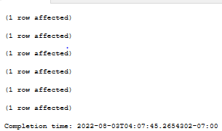

select * from student;

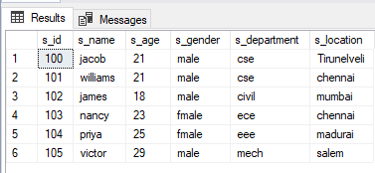

|  |  |  |  |  |  |
| --- | --- | --- | --- | --- | --- |
| S_id | S_name | S_age | S_genter | S_department | S_locatiom |
| 100 | Jacob | 21 | Male | Cse | Tirnelveli |
| 101 | Williams | 21 | Male | Cse | Chennai |
| 102 | James | 18 | Male | Civil | Mumbai |
| 103 | Nancy | 23 | Female | Ece | Chennai |
| 104 | Priya | 25 | Female | Eee | Madurai |
| 105 | victor | 29 | male | mech | Salem |

**SQL SELECT** :

The SELECT statement is used to select data from a database.

The data returned is stored in a result table, called the result-set.

Syntax :

SELECT column1, column2, ...  
FROM table_name

Example :

select s_name,s_age,s_department from student;

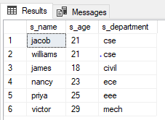

|  |  |  |
| --- | --- | --- |
| S_name | S_age | S_department |
| Jacob | 21 | Cse |
| Williams | 21 | Cse |
| James | 18 | Civil |
| Nancy | 23 | Ece |
| Priya | 25 | Eee |
| victor | 29 | Mech |

**SQL DELETE** :

The DELETE statement is used to delete existing records in a table.

Syntax :

DELETE FROM table_name WHERE condition;

Example:

delete from student where s_name='victor’

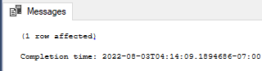

select * from student;

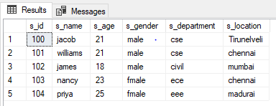

**DAY 3**

**SQL WHERE CLAUSE :**

The WHERE clause is used to filter records.

It is used to extract only those records that fulfill a specified condition.

Syntax:

SELECT column1, column2, ...  
FROM table_name  
WHERE condition;

Example:

select * from student where s_gender='male'

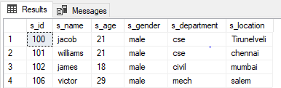

select * from student where s_age>21

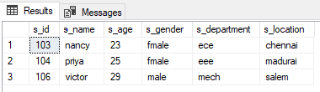

select * from student where s_id<103

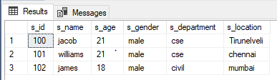

select * from student where s_age>=21

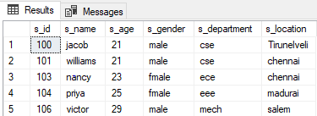

select * from student where s_id<=103

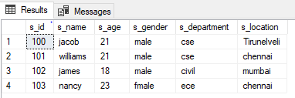

select * from student where s_department!='cse'

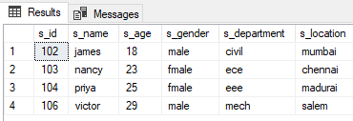

select * from student where s_age between 23 and 29

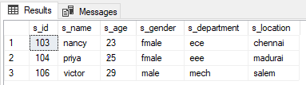

select * from student where s_gender like 'f%'

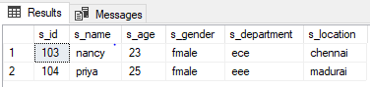

select * from student where s_age like '2_'

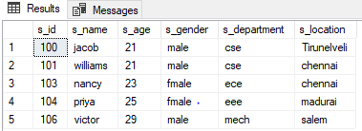

select * from student where s_location in ('Tirunelveli','madurai')

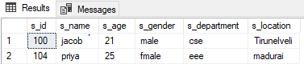

**SQL UPDATE STATEMENT :**

The UPDATE statement is used to modify the existing records in a table.

Syntax :

UPDATE table_name  
SET column1 = value1, column2 = value2, ...  
WHERE condition;

Example :

update student set s_name='kutty' where s_id=104

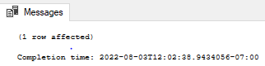

select * from student;

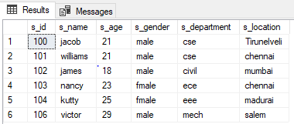

update student set s_department='IIT' where s_gender='fmale'

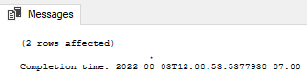

select * from student;

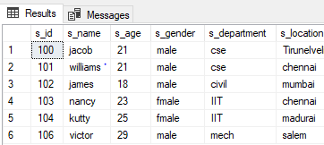

**SQL OPERATORS :**

The WHERE clause can be combined with AND, OR, and NOT operators.

The AND and OR operators are used to filter records based on more than one condition.

The NOT operator displays a record if the condition(s) is NOT TRUE.

Example :

select * from student where s_department='IIT' and s_location='chennai'

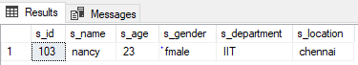

select * from student where s_department='IIT' or s_location='chennai'

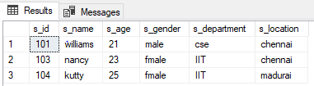

select * from student where not s_department='IIT'

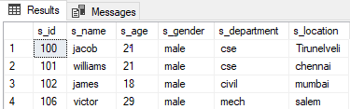

select * from student where s_department='IIT' and (s_location='chennai' or s_location='madurai')

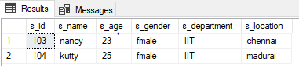

select * from student where not s_department='cse' and not s_location='chennai'

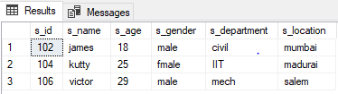

**HAVING CLAUSE :**

Having clause is used in combination with group by to impose condition on groups.

Syntax:

SELECT column_name(s)  
FROM table_name  
WHERE condition  
GROUP BY column_name(s)HAVING conditionORDER BY column_name(s);

Example:

select * from employee;

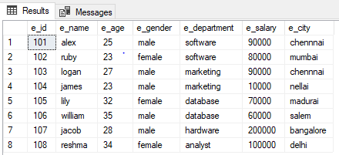

select e_department,avg(e_salary) as avg_salary

from employee

group by e_department

having avg(e_salary)>70000

order by avg(e_salary) desc;

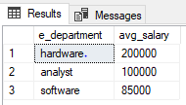

select e_department,count(e_id) as total

from employee

where e_salary>75000

group by e_department

having count(e_id)>=1

order by count(e_id) desc;

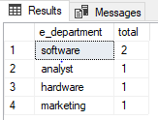

**DAY 4**

**SQL ORDER BY :**

The ORDER BY keyword sorts the records in ascending order by default. To sort the records in descending order, use the DESC keyword.

Syntax :

SELECT column1, column2, ...  
FROM table_name  
ORDER BY column1, column2, ... ASC|DESC;

Example :

select * from student order by s_age asc;

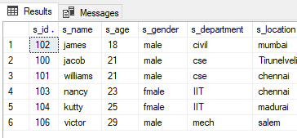

select * from employee order by e_salary desc;

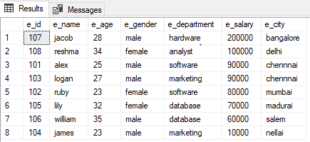

select s_name,s_age from student order by s_age;

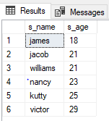

select e_name,e_department,e_salary from employee order by e_salary desc;

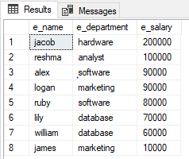

select * from student order by s_age asc, s_name desc;

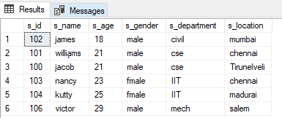

**SQL GROUP BY :**

The GROUP BY statement is often used with aggregate functions (COUNT(), MAX(), MIN(), SUM(), AVG()) to group the result-set by one or more columns.

Syntax :

SELECT column_name(s)  
FROM table_name  
WHERE condition  
GROUP BY column_name(s)ORDER BY column_name(s);

Example :

select e_department, avg(e_salary) as avg_salary

from employee

group by e_department;

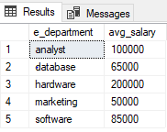

select s_age,count(s_id) as total

from student

group by s_age;

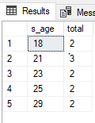

select e_department,max(e_salary) as max_salary

from employee

group by e_department;

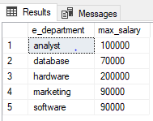

select s_gender,min(s_age) as h_age from student

group by s_gender;

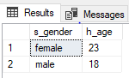

select e_department,count(e_id) as total

from employee

where e_salary>50000

group by e_department

order by count(e_id) desc;

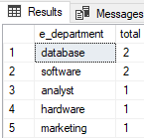

select e_department, sum(e_salary) as sum_of_salary

from employee

group by e_department

order by sum(e_salary) asc;

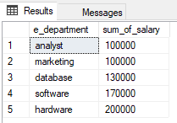

**AGGREGATE FUNCTION :**

MAX :

The MAX() function returns the largest value of the selected column

Syantax :

SELECT MAX(column_name)  
FROM table_name  
WHERE condition;

Example :

select max(e_salary) as max_salary

from employee;

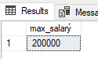

select max(e_salary) as max_salary,e_department

from employee

where e_department='marketing'

group by e_department;

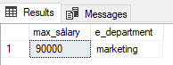

MIN :

The MIN() function returns the smallest value of the selected column

Syantax :

SELECT MIN(column_name)  
FROM table_name  
WHERE condition;

Example :

select min(s_age) as min_age from student

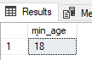

select min(s_age) as min_age,s_gender

from student

where s_gender='female'

group by s_gender;

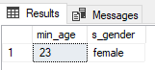

AVG :

The AVG() function returns the average value of a numeric column.

Syantax :

SELECT AVG(column_name)  
FROM table_name  
WHERE condition;

Example :

select avg(e_salary) as avg_salary

from employee;

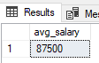

select avg(e_salary) as avg_salary,e_department

from employee

where e_department='database'

group by e_department;

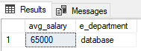

COUNT :

The COUNT() function returns the number of rows that matches a specified criterion.

Syantax :

SELECT COUNT(column_name)  
FROM table_name  
WHERE condition;

Example :

select count(*) as Total_student from student;

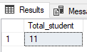

select count(*) as Total_student ,s_gender

from student

group by s_gender;

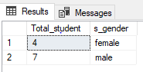

SUM :

The SUM() function returns the total sum of a numeric column.

Syantax :

SELECT SUM(column_name)  
FROM table_name  
WHERE condition;

Example :

select sum(e_salary) as sum_of_salary

from employee;

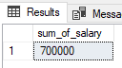

select sum(e_salary) as sum_of_salary,e_department

from employee

where e_department='software'

group by e_department;

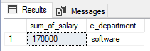

DROP :

The DROP statement is used to drop an existing SQL database and table.

Example :

alter table students

drop column s_genter;

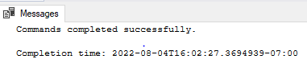

drop database world;

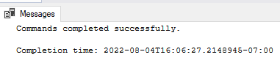

use world;

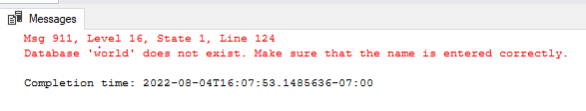

**DAY 5**

**SQL JOIN :**

A JOIN clause is used to combine rows from two or more tables, based on a related column between them.

Types :

* INNER JOIN
* LEFT JOIN
* RIGHT JOIN
* FULL JOIN

INNER JOIN :

The INNER JOIN keyword selects records that have matching values in both tables.

Syntax :

SELECT column_name(s)  
FROM table1  
INNER JOIN table2ON table1.column_name = table2.column_name;

Example :

select s.s_name,s.s_department,sf.sf_fees

from students as s

inner join students_fee as sf

on s.s_id=sf.sf_id;

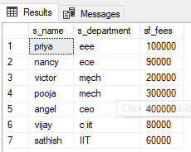

## LEFT JOIN :

The LEFT JOIN keyword returns all records from the left table (table1), and the matching records from the right table (table2). The result is 0 records from the right side, if there is no match.

### Syntax :

SELECT column_name(s)  
FROM table1  
LEFT JOIN table2ON table1.column_name = table2.column_name;

Example :

select s.s_name,s.s_department,sf.sf_fees

from students as s

left join students_fee as sf

on s.s_id=sf.sf_id;

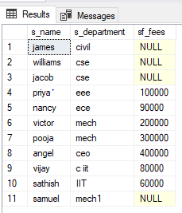

**RIGHT JOIN :**

The RIGHT JOIN keyword returns all records from the right table (table2), and the matching records from the left table (table1). The result is 0 records from the left side, if there is no match.

### Syntax :

SELECT column_name(s)  
FROM table1  
RIGHT JOIN table2ON table1.column_name = table2.column_name;

Example :

select s.s_name,s.s_department,sf.sf_fees

from students as s

right join students_fee as sf

on s.s_id=sf.sf_id;

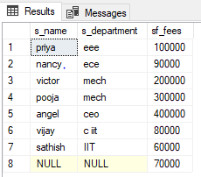

## FULL JOIN :

The FULL OUTER JOIN keyword returns all records when there is a match in left (table1) or right (table2) table records.

### Syntax :

SELECT column_name(s)  
FROM table1  
FULL OUTER JOIN table2ON table1.column_name = table2.column_nameWHERE condition;

Example :

select s.s_name,s.s_department,sf.sf_fees

from students as s

full join students_fee as sf

on s.s_id=sf.sf_id;

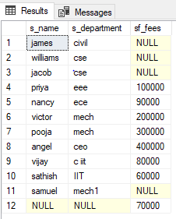

**DAY 6**

**BETWEEN :**

The BETWEEN operator selects values within a given range. The values can be numbers, text, or dates.

Syntax :

SELECT *column_name(s)*  
FROM *table_name*  
WHERE *column_name*BETWEEN *value1* AND *value2;*

Example :

select * from student where s_age between 23 and 29;



## LIKE :

The LIKE operator is used in a WHERE clause to search for a specified pattern in a column.

Syntax :

SELECT column1, column2, ...  
FROM table_name  
WHERE columnN LIKE pattern;

Example :

select * from student where s_gender like 'f%'



select * from student where s_age like '2_'



## Aliases :

SQL aliases are used to give a table, or a column in a table, a temporary name.

An alias is created with the AS keyword.

Syntax :

SELECT *column_name* AS *alias_name*  
FROM *table_name;*

*Example :*

select s.s_name,s.s_department,sf.sf_fees

from students as s

inner join students_fee as sf

on s.s_id=sf.sf_id;

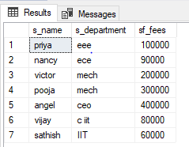

## UNION :

The UNION operator is used to combine the result-set of two or more SELECT statements.

Syntax :

SELECT *column_name(s)* FROM *table1*  
UNION  
SELECT *column_name(s)* FROM *table2*;

Example :

select * from student

union

select * from students;

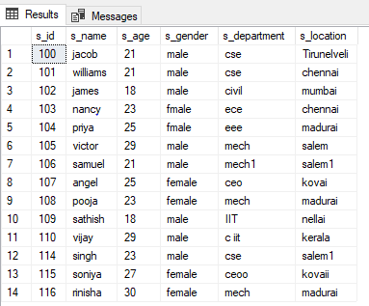

select * from student

where s_department='cse'

union

select * from students

where s_department='cse'

order by s_department;

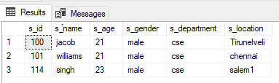

**UNION ALL :**

Union all operator gives all the rows from both the tables including the duplicates.

Syntax :

SELECT column_name(s) FROM table1  
UNION ALL  
SELECT column_name(s) FROM table2;

Example :

select * from student

union all

select * from students;

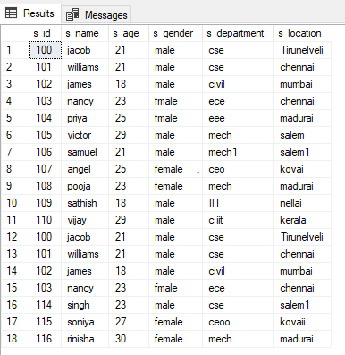

**Except :**

Except operator combines two select statement and returns unique records from the

Left query which are not part of the right query.

Syntax :

SELECT column_name(s) FROM table1  
Except  
SELECT column_name(s) FROM table2;

Example :

select * from student

except

select * from students;

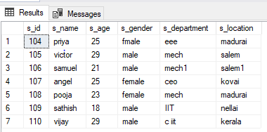

**INTERSECT :**

Intersect operator helps to combine two select statement and returns

The records with are common to both the select statement.

Syntax :

SELECT column_name(s) FROM table1  
Intersect  
SELECT column_name(s) FROM table2;

Example :

select * from student

intersect

select * from students;

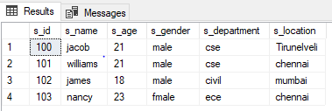

**DAY 7 :**

**CASE :**

Case statement helps in multi way decision making.

Syntax :

CASE  
    WHEN condition1 THEN result1  
    WHEN condition2 THEN result2  
    WHEN conditionN THEN resultN  
    ELSE result  
END;

Example:

select e_name,e_salary,e_level=

case

when e_salary>=100000 then 'senior employee'

when e_salary>=50000 then 'junior employee'

else 'intern'

end

from employee

go;

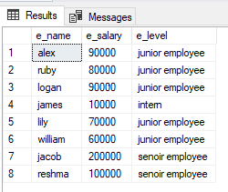

**DATE :**

**SQL Server** comes with the following data types for storing a date or a date/time value in the database:

* DATE - format YYYY-MM-DD
* DATETIME - format: YYYY-MM-DD HH:MI:SS
* SMALLDATETIME - format: YYYY-MM-DD HH:MI:SS
* TIMESTAMP - format: a unique number

Example :

alter table employee add e_join_date date;

update employee set e_join_date='2022-08-10'

where e_name='alex';

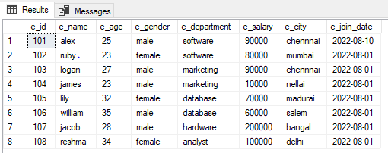

**SUB QUERY :**

A subquery is a query that appears inside another query statement. Subqueries are also referred to as sub- SELECT s or nested SELECT s. The full SELECT syntax is valid in subqueries.

Syntax :

SELECT ALL column_name(s)  
FROM table_name  
WHERE condition(select column_name from table name);

Example :

select * from employee

where e_salary=(select min(e_salary) from

employee);

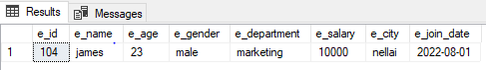

**RANK :**

If you have three items at rank 3, then the next rank listed would be rank 5. It will skip the next available ranking value.

Example :

select e_name,e_salary,e_department,

rank() over (order by e_salary desc) as rank_over,

dense_rank() over (order by e_salary desc) as dense_rank_over,

row_number() over (order by e_salary desc)as row_number_over

from employee;

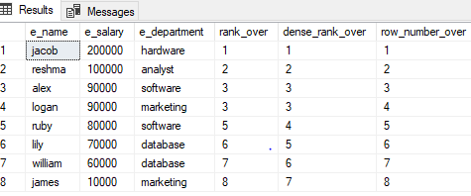

**DAY 10**

**SUB QUERY :**

A subquery is a query that appears inside another query statement. Subqueries are also referred to as sub- SELECT s or nested SELECT s. The full SELECT syntax is valid in subqueries.

Syntax :

SELECT ALL column_name(s)  
FROM table_name  
WHERE condition(select column_name from table name);

Example :

select * from employee

where e_salary=(select min(e_salary) from

employee);



select * from employee

where c_department_id=(select c_department_id from company

where c_department='software');

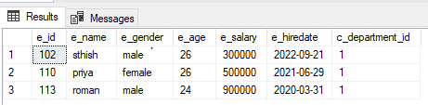

select * from employee

where e_salary=(select max(e_salary)

from employee);

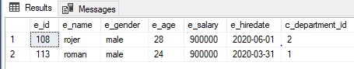

select * from employee

where e_id in (select e_id from employee

where e_salary>500000);

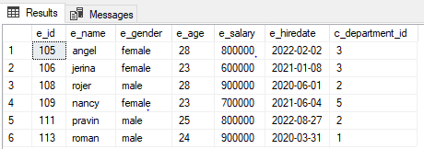

update employee

set e_salary=e_salary * 0.25

where e_age in (select e_age from employee

where e_age>=26);

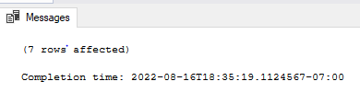

select * from employee;

